Implement of a New Runge-Kutta Method for the System with Uncertain Discontinuous Change

Jiechao Wang, Peiqing Han

December 22, 2015

I. Introduction

There are some systems whose components change suddenly. For example, in ball rebounding system, the ball’s speed reverses and the state change discontinuously. Also, a system changes before and after a jump in an instant like a jump robot.

When we do the simulation of those systems, the simulator must detect a change precisely which takes place suddenly and discontinuously. The popular Runge-Kutta method has the same accuracy as the limited approximation of Taylor series expansion but it can’t solve this kind of problems very well.

In this report, we studied and implemented a new method in which the discontinuous change is considered strictly by improving the Runge-Kutta method.

II. Problem Formulation

Considering the system of rebounding of a ball as an example. The model is shown in Figure 1 and Figure 2.

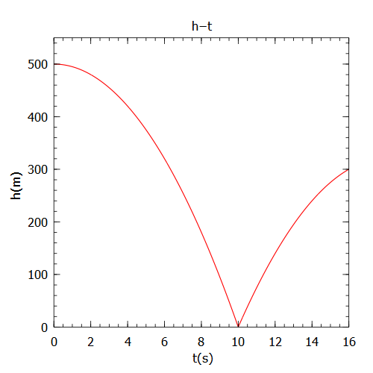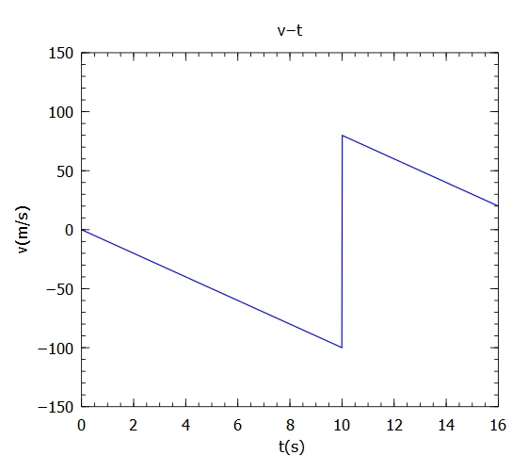

Figure 1: Position of the ball Figure 2: Speed change with rebounding

|  |  |
| --- | --- |
| Table 1: Parameter reference | |
| Name | Symbol |
| free-fall gravity | $g$ = $10m/s^{2}$ |
| vertical velocity | $$v$$ |
| current position | $$h$$ |
| coefficient of restitution | $e$ =0.8 |

Using the Newton’s laws of motion, we could get the formula of the position and speed of the ball

$$v\left(t\right)=v_{0}-gt$$

$$v(t)=\frac{dh(t)}{dt}$$

Assume the ball falls from the altitude of $h_{0}$ we could calculate the time when the ball hit to the ground

$$h_{0}-0=\frac{g{t_{change}}^{2}}{2}$$

Then, the ball is rebounded by the ground in a very short time, considering the coefficient of restitution

$$v_{reb}=-ev\left(t_{change}\right)$$

Finally, the ball follows a vertically upward projectile motion. The function is plot in the Figure 2.

$$v\left(t\right)=v_{reb}-g(t-t_{change})$$

So, the ODE is

$$\dot{h}\left(t\right)=\left\{\begin{aligned}-gt 0<t≤t_{change} \\ v_{reb}-g\left(t-t_{change}\right) t>t_{change}\end{aligned}\right.$$

We could see that it’s a linear first order ODE. But actually it’s Lipschitz continuous in both part. And only 1 point doesn’t meet the condition. Standard Runge-Kutta method costs too much time to calculate the change point. And there is an offset after the change point.

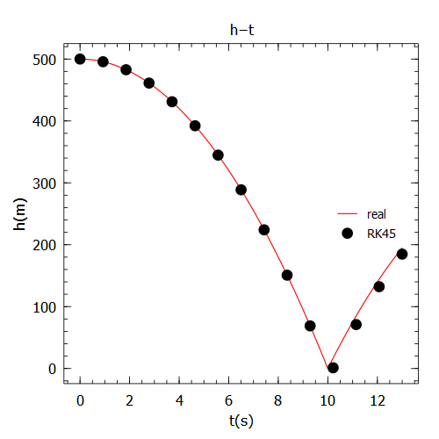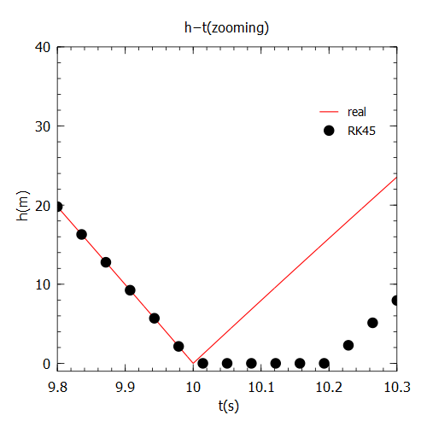

Figure 3: RK45 method’s result Figure 4: Offset after the change point

III. Solution Method

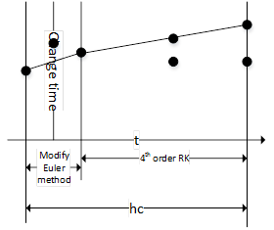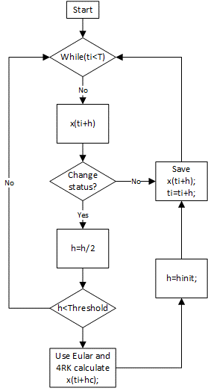

Figure 5: New Runge-Kutta method

Figure 6: Step size control around the change point

We determine the change time for the systems which change discontinuously by step-size control RK45 (Dormand-Prince). The flow charts are in the Figure 5.

If x(t+h) doesn’t meet the condition the change has occurred, we will arrive the next step. Otherwise, we get half of our step size until h is smaller our threshold. When h meets the condition, we will combine the modify Euler method with the 4th order RK to pass the change time by fix step hc, but only once.

After passing the discontinuous point, we will restart RK45 method to estimate the orbit.

IV. Numerical Results

Assume that the ball falls from $h_{0}$ =500m. Using our new Runge-Kutta method, we can get the plot of the ball’s position, showed in Figure 7 and Figure 8. It’s more accurate than the result of standard RK45 method.

In addition, the new method has a good efficiency and it use the RK45 in continuous part.

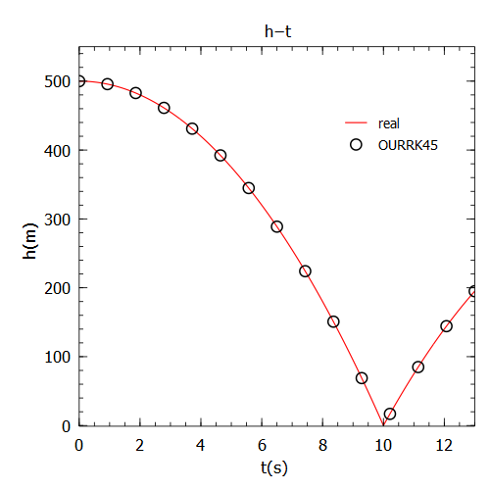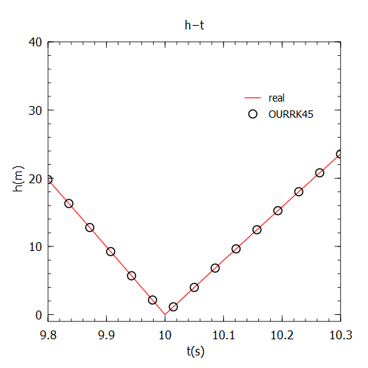

Figure 7: Position of the ball Figure 8: Speed change with rebounding

Considering a more complicated system of a ball rebounded twice. So the ODE has 2 discontinuous points. This time we are trying to observe each step it use. Figure 9 and Figure 10 show the result. Firstly, it can solve this problem accurately. And the performance of step size control around change point is expected. The step becomes smaller and smaller to fit the change point. After the change this method is same as RK45 and detecting the next change.

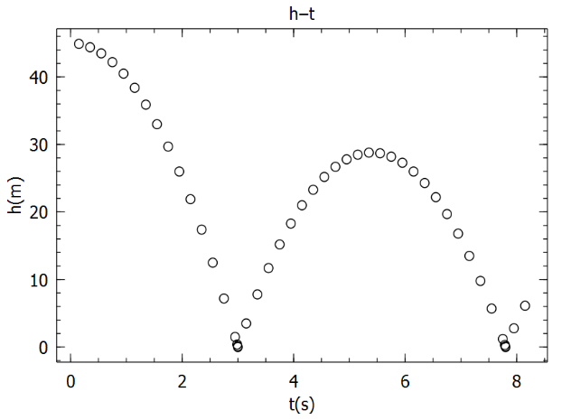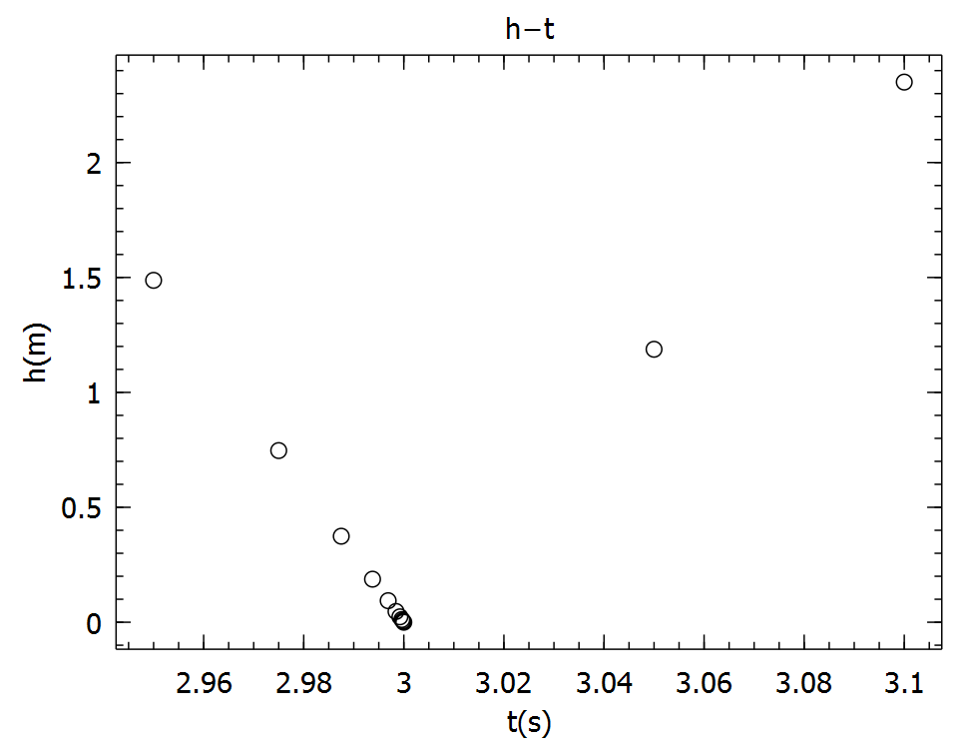

Figure 9: Position of the ball Figure 10: Speed change with rebounding

V. Conclusion

In this report, we implement a new Runge-Kutta method to solve some simple systems whose state change discontinuously.

Firstly we studied RK45 with step size control method and found its defect. Then, referencing some paper, we improved RK45. It works similar as RK45 but the new method could detect discontinuous change and decrease step size to fit change point accurately.

References

1. Richard L. Burden, J. Douglas Faires, Numerical Analysis 7th Edition
2. Masanobu Koga, Nachi Tanimura, Tsuyoshi Sato, Numerical simulation suing Runge-Kutta method for the system with uncertain discontinuous change. IEEE SICE 2002. Proceedings of the 41st SICE Annual Conference.